**CENWP-OD-B12 July 2023**

**MEMORANDUM FOR THE RECORD**

**SUBJECT: 23BON054 MFR BI LPS RB2 Pacific Lamprey Mort**

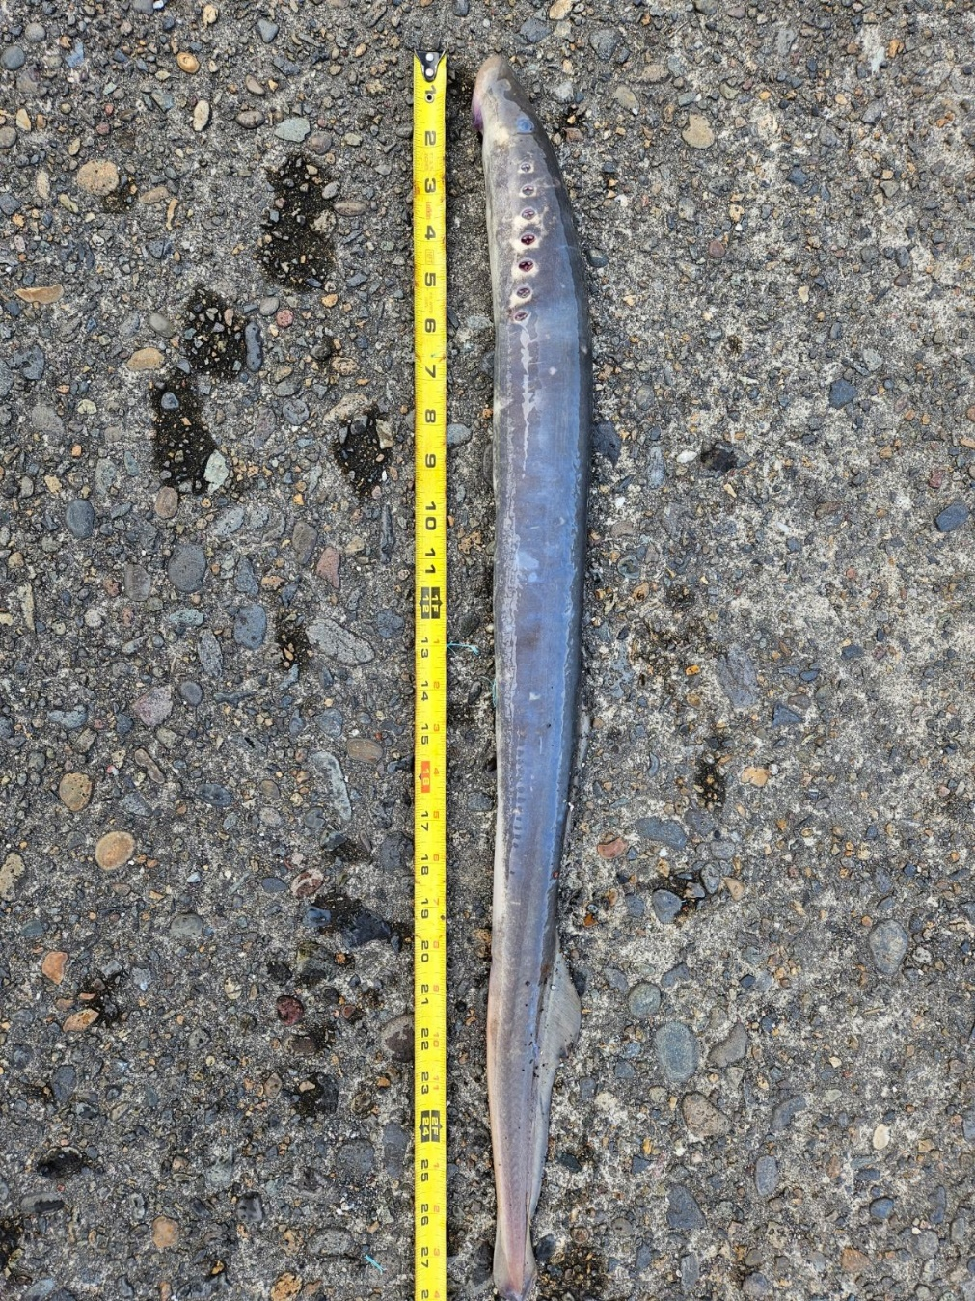On the morning of 11 July, Project Biologists discovered one adult Pacific Lamprey mortality in the Bradford Island LPS Rest Box 2 (BI LPS RB2). The fish was scanned for PIT tags, inspected, and returned to the river.

1. Species – Pacific Lamprey (*Entosphenus tridentatus)*
2. Origin – Unknown
3. Length – 71.1 cm
4. Marks and tags – None
5. Marks and Injuries found on carcass – None
6. Cause and Time of Death – Unknown
7. Future and Preventative Measures – None

Sincerely,

Bonneville Project Fisheries